**1.JAVA VOTING PROGRAM**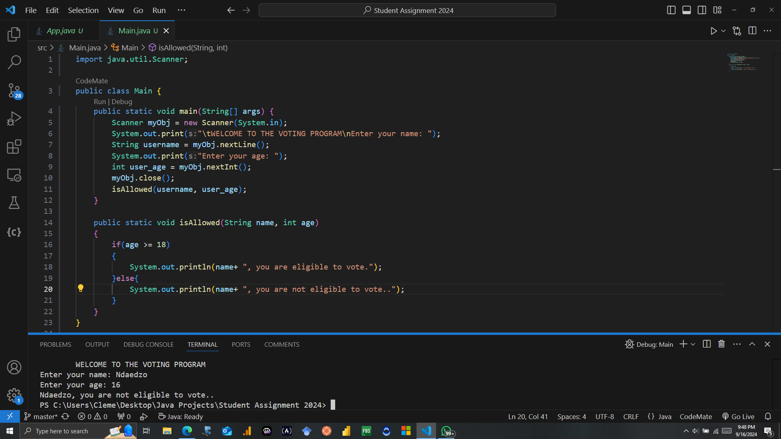

**2.MASM VOTING PROGRAM**

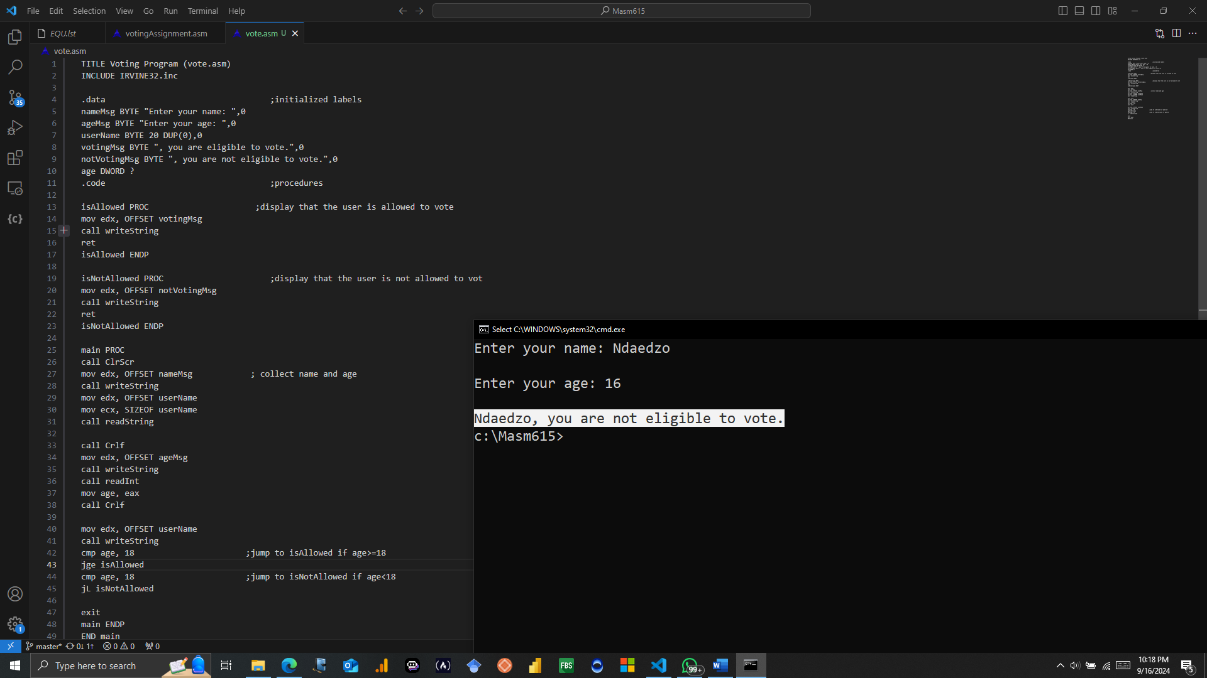

**3.FLOW CHART**

**4.PSEUDOCODE**

**Declare Data**

`nameMsg`: Prompt for user's name

`ageMsg`: Prompt for user's age

`userName`: Stores the user's name

`votingMsg`: Message for eligible voters

`notVotingMsg`: Message for ineligible voters

`age`: Stores user's age

**Main Procedure**

- Clear screen. call ClrScr

- Prompt and read the user's name.

- Prompt and read the user's age.

- Display the user's name.

- If age >= 18, call `isAllowed`, else call `isNotAllowed`.

- Exit the program**.**

**Print “ Eligible to vote”**

**Print “ Not eligible to vote”**

**No**

**Yes**

**Is userAge >= 18**

**Enter your age**

**Enter your name**